**EXP 2:**

**Q2.use matrix of 3 by 5 matrix for dispalaying 3 students and 5 subjects.**

print("matrix of student roll and mmarks")

r=0

c=0

r=as.numeric( readline("enter Row "))

c=as.numeric( readline("enter col "))

std=c()

sub=c()

cat("enter stud names ",r)

for(x1 in 1:r)

{

std[x1]=c(readline("enter stud names"))

}

for(x1 in 1:c)

{

sub[x1]=c(readline("enter sub names"))

}

t=r*c

cat("Total datas to enter=",t)

k=1

print (t)

m=c()

for(x1 in 1:t)

{

if (k<=c){

cat("enter marks for",sub[k],"of",std[k])

k=k+1

}

else{

k=1

cat("enter marks for",sub[k],"of",std[k])

k=k+1

}

m[x1]=c(as.integer(readline()))

}

cat("sub=",sub)

cat("std=",std)

print(m)

mmm=matrix(m,r,c,0,list(std,sub))

print(mmm)

print(rowSums(mmm))

total=c(rowSums(mmm))

tt=total

print(tt)

mmm=cbind(mmm,total)

print(mmm)

result=c(1:3)

ll=c()

for ( ll in 1:total){

if(total[ll] >= 75 ){

result[ll]="Disti"

}

else if(total[ll]>= 65 ){

result[ll]="1st"

}

else if(total[ll]>= 40 ){

result[ll]="pass"

}

else{

result[ll]="fail"

}

}

per=c()

pp=1

print(total)

for(pp in 1:total)

{

per[pp]=(total[pp]/5)*100

}

print(result)

mk=cbind(mmm,result)

print(mk)

**OUTPUT**

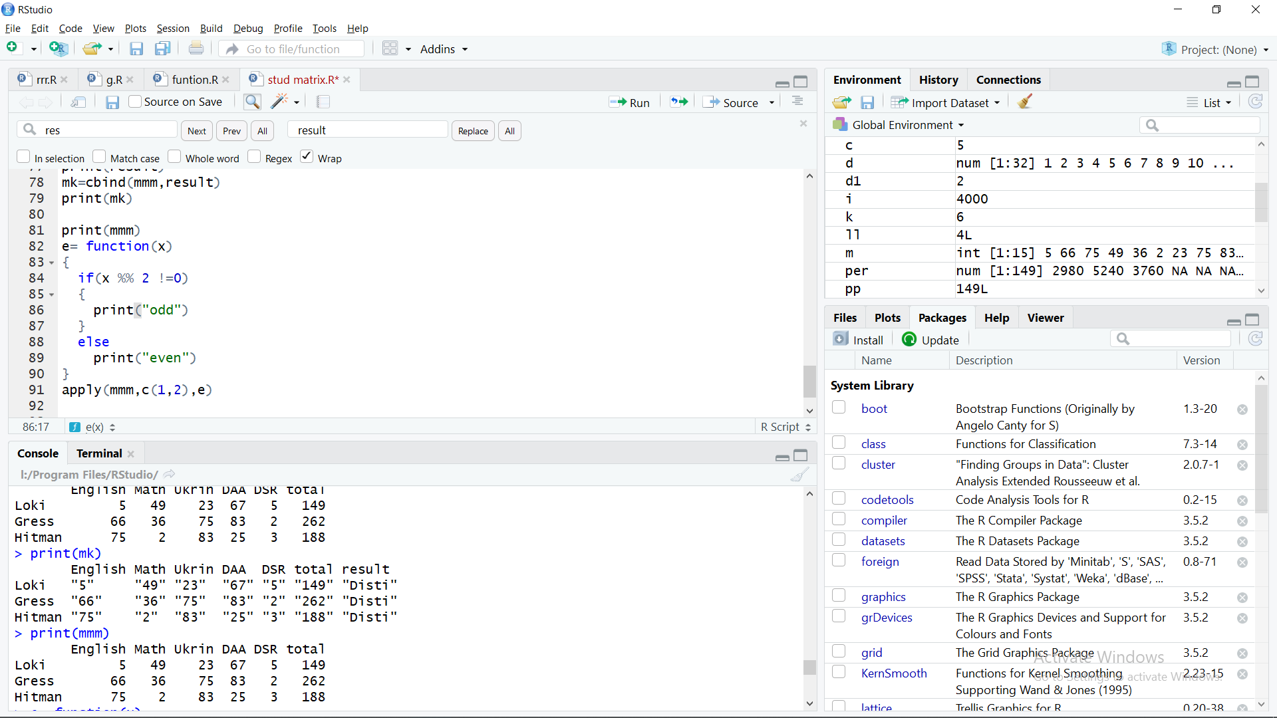

**Q3>Apply function in R**

print(mmm)

e= function(x)

{

if(x %% 2 !=0)

{

print("odd")

}

else

print("even")

}

apply(mmm,c(1,2),e)

**OUTPUT:**

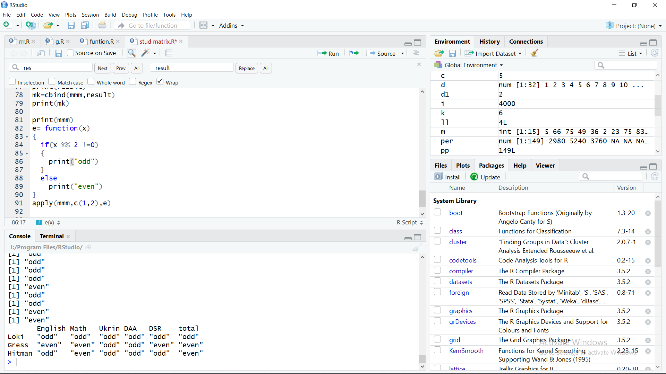

**Q1user R script for following matrix and do matrix multipicaton**

d1=c(7,9,12,2,4,13)

d2=c(1,7,12,19,2,8,13,20,3,9,14,21)

mar1=matrix(d1,2,3,1)

mar2=matrix(d2,3,4,1)

print(mar1)

print(mar2)

print(mar1 %*% mar2)

**OUTPUT**

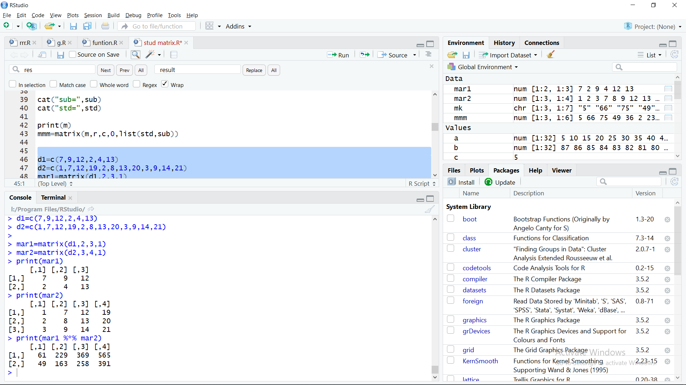

**EXP 1:**

**Q1 create vector in R**

lop=seq(5,160,5)

kop=c(87:56)

print(lop)

print(kop)

**OUTPUT**

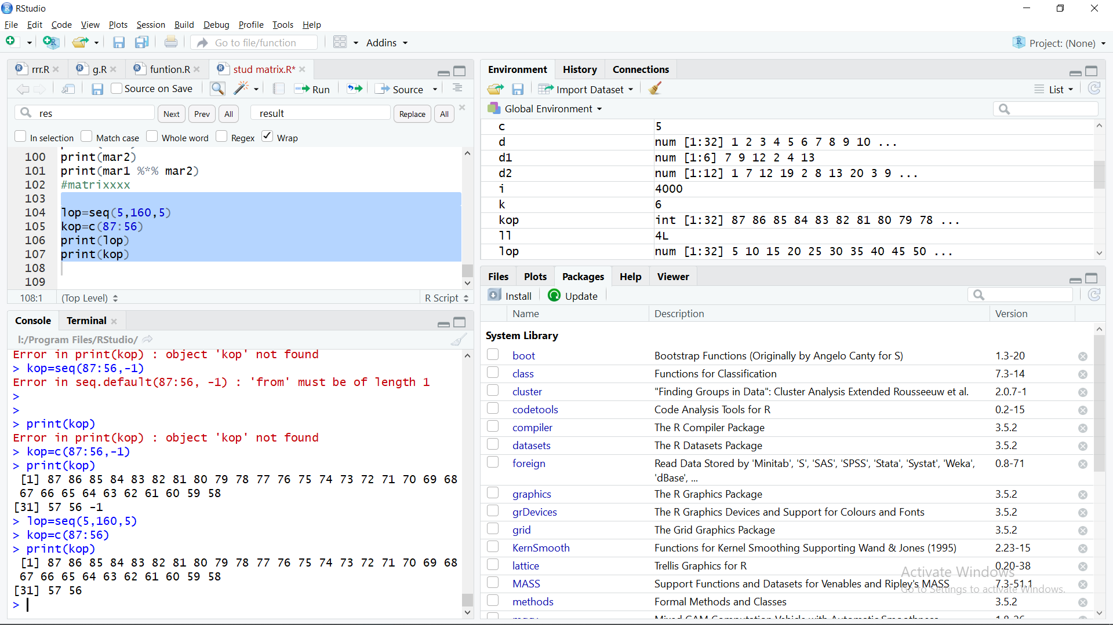

Q2. 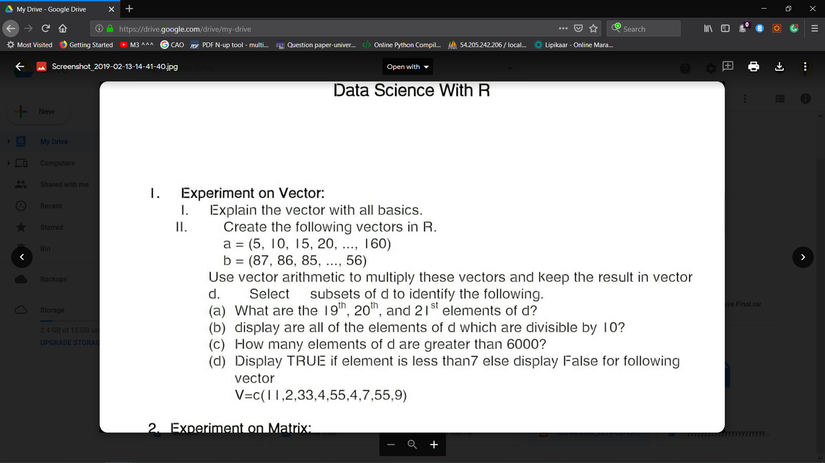

d=c(1:30,4000,7000)

d1=c(2)

d=d1*d

print(d)

for (i in d){

if((d[i] %/% 10) ==0) {

print(d[i])

}

}

i=1

m=1

for (i in d)

{

if(d[i]>7000){

m=m+1

}

}

cat("number grater than 7000 are total ",m,"numbers")

